Ideation Phase
Brainstorm & Idea Prioritization

Date | 28 September 2026
Team ID | SWTID-2026-3101
Project Name | BlogNestAPI
Maximum Marks | 4 Marks

Brainstorm & Idea Prioritization:
The Brainstorming process for BlogNestAPI focused on identifying the essential features required to build a simple, reliable, and user-friendly blogging platform. Several ideas were considered, including user registration and login, creating and editing blogs, deleting blogs, viewing all blogs, searching and filtering blogs, adding comments and likes, and managing categories and tags. These ideas were prioritized based on their importance, ease of implementation, and value to users. The core features selected for the initial version were creating, viewing, updating, and deleting blog posts using a REST API. MongoDB was selected for data storage, Node.js and Express.js were chosen for backend development, and Thunder Client was selected for API testing. Advanced features such as authentication, comments, likes, search, and pagination can be added in future versions. This prioritization helps develop BlogNestAPI step by step while focusing first on the most important blogging functions..

Step-1: Team Gathering, Collaboration and Select the Problem Statement
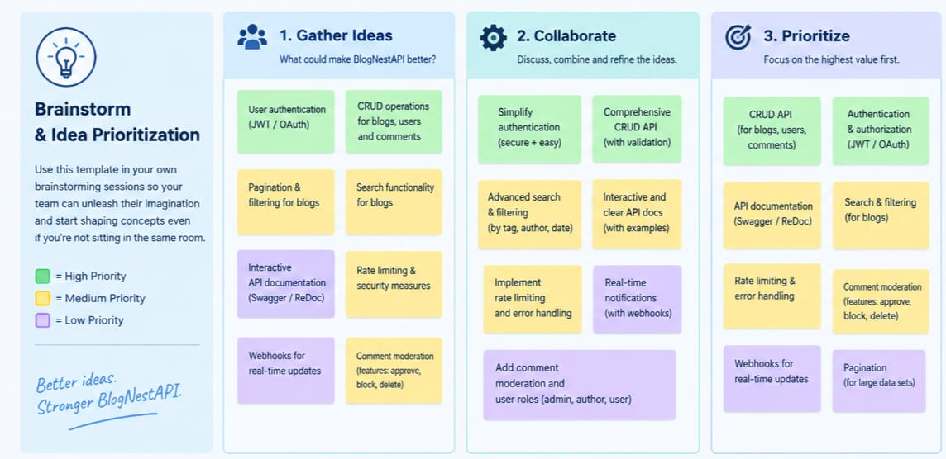

Step-2: Idea Prioritize:
